

Project Report
On
RECIPES GENERATOR

Submitted By:
Name: BHARATH JR URN :RTU24101CS020
Name: DARSHAN L URN: RTU24101CS0027
Name: RITHISH URN: RTU24101CS0001
Name: MONIK URN: RTU24101CS0022

Program Name: B.TECH CSE AIML
SUBJECT: MACHINE LEARNING
Semester: 3Rd Sem
Session: 2025-2026

Submitted To:
Faculty Name: SATYAM SIR
College of Engineering & Application
Rai Technology University

Table of Contents

•Content's •Pages No.

1) Certificate ............................................................ 2)Declaration ...........................................................

3) Abstract .............................................................. 4)Introduction ........................................................
5)Objective .........................................................
6) Literature Review ............................................
7)Methodology ...................................................
8)Implementation / System Design ....................
9)Code Explanation ............................................
10)Results and Discussion ....................................
11)Conclusion .......................................................

1]Certificate
This is to certify that the project entitled " Recipes Generator " has been genuinely and originally carried out by Bharath JR , Darshan L , Monik and Rithish under the valuable guidance and supervision of Mr. Rupam Sarmah. The project work has been successfully completed as a part of the partial fulfillment of the requirements for the award of the degree of Bachelor of Technology at Rai Technology University.
We hereby declare that the project report submitted is an authentic and original piece of work done by the students themselves and has not been submitted, either in whole or in part, to any other university or institution for any degree or academic award.
We appreciate the sincere efforts and dedication shown by the students in the completion of this project, which demonstrates their understanding and application of advanced concepts in voice recognition technology and smart assistant development.
Date:  Place: ___________ |  | ___________
(Signature of guide)
Mr. Satyam sir

_______________________ Guide's Signature

_______________________ Head of Department's Signature

2]Declaration

We hereby solemnly declare that the project report entitled "Recipes Generator ", submitted to Rai Technology University, is our original and authentic work carried out by us under the guidance and supervision of our faculty. We affirm that this project report has not been submitted, either in part or in full, to any other university, institution, or organization for the award of any degree, diploma, or certification, nor has it been published elsewhere.

We have made every effort to ensure that the content of this report is our own, and all sources of information and references used in the preparation of this report have been duly acknowledged. We understand the importance of academic integrity and certify that this work meets the ethical standards of originality and honesty.

We take full responsibility for the authenticity and accuracy of the data, analysis, and conclusions presented in this project report. We also acknowledge that any violation of the above statements may lead to appropriate disciplinary action by the university.
This declaration is made on this day [24 / sep / 2025] at Rai Technology University.

_____________________________________Student's Signature

3)Abstract
The development of intelligent systems that can provide personalized food recommendations has gained increasing relevance with the rapid growth of digital platforms, lifestyle changes, and the demand for convenience in everyday cooking. This project focuses on designing and implementing a Recipe Generator Model capable of suggesting suitable recipes based on the set of ingredients provided by the user. The system leverages a dataset of recipes obtained from publicly available sources such as Kaggle, which includes information such as recipe names, ingredients, directions, cuisine types, and ratings. Unlike static recipe books, this model dynamically interacts with the user by asking which ingredients they currently have at hand, and then recommending dishes that can be prepared using those items.
The methodology involves a multi-step process, beginning with data preprocessing, where raw recipe data is cleaned, tokenized, and normalized to ensure uniformity across ingredient lists. This is followed by the implementation of ingredient matching algorithms, where user-provided ingredients are compared against recipe datasets using substring matching, word-boundary checks, and potential fuzzy matching techniques to account for variations in naming, plurals, and misspellings. The system computes a matching score for each recipe based on the overlap between user-provided ingredients and the recipe’s required ingredients. Recipes with the highest overlap are prioritized, while additional details such as missing ingredients, cuisine type, and stepwise cooking directions are also presented to enrich the user’s experience.
The uniqueness of the proposed system lies in its interactive nature, as it mimics real-world decision-making in kitchens where users often plan meals based on the limited availability of ingredients rather than a fixed menu. Furthermore, the project demonstrates the potential of combining natural language processing (NLP), data representation techniques, and recommendation system logic to solve practical everyday challenges. The model is designed to be extensible, meaning it can be integrated into user-friendly interfaces such as Streamlit web applications or voice-based assistants, enabling hands-free cooking assistance.
The outcomes of this project highlight the advantages of intelligent recommendation systems in promoting resource efficiency, reducing food wastage, and encouraging users to explore a diverse set of cuisines without requiring extensive manual searching. By bridging the gap between user needs and available digital culinary data, the Recipe Generator Model not only simplifies cooking decisions but also contributes to the growing trend of AI-driven smart assistants in the domain of food technology. This project thus lays the foundation for more advanced systems that can incorporate dietary restrictions, nutritional values, and user preferences, thereby providing a comprehensive, personalized cooking assistant for modern households.

4) Introduction
Food is an integral part of human life, not only serving as a basic necessity but also playing a vital role in culture, tradition, and lifestyle. In today’s fast-paced world, individuals often struggle with the daily challenge of deciding what to cook with the ingredients available at home. While recipe books and online food blogs provide a wide range of options, they require extensive searching and filtering, which can be time-consuming and overwhelming for users. Additionally, people may not always have access to every ingredient required in a recipe, leading to confusion or wastage of available resources. This gap highlights the need for a system that can intelligently suggest recipes based on the ingredients already present in the user’s kitchen.
The advancement of Artificial Intelligence (AI) and Machine Learning (ML) provides opportunities to address this problem by creating intelligent recommendation systems. Recipe generation and recommendation fall under the broader category of recommender systems, which are widely used in domains such as e-commerce, entertainment, and healthcare. By applying similar concepts to the culinary domain, AI can simplify decision-making in cooking, encourage creativity, and reduce dependency on traditional recipe search methods.
This project focuses on the design and development of a Recipe Generator Model that takes user input in the form of available ingredients and generates a list of recipes that can be prepared using those items. The model uses a dataset of recipes collected from Kaggle, which includes details such as recipe names, ingredients, directions, ratings, and cuisine categories. The ingredients are preprocessed to ensure consistency, and a matching algorithm is employed to compare user-provided ingredients with the dataset. Recipes with the highest overlap are suggested, along with additional metadata such as cuisine type, preparation directions, and ratings to assist the user in making an informed choice.
The system stands out due to its interactive approach, where users can simply input a list of items they have at hand—such as tomatoes, onions, rice, or butter—and instantly receive personalized recipe suggestions. This not only saves time but also minimizes food wastage by encouraging users to utilize ingredients they already possess. Furthermore, the project demonstrates the integration of data processing, natural language techniques, and user-friendly interaction, making it a practical solution for households, restaurants, and food enthusiasts.
In summary, this project introduces an AI-powered tool designed to enhance the cooking experience by transforming available ingredients into complete meal ideas. It bridges the gap between raw data and real-world usability, paving the way for future enhancements such as nutritional filtering, dietary customization, and integration into smart kitchen assistants.

5)Objective

The main objectives of the Recipe Generator Model are:
- To design and develop an AI-based recipe recommendation system that suggests dishes based on ingredients available with the user.
- To preprocess and structure raw recipe data (ingredients, directions, cuisine type, ratings) from the Kaggle dataset for effective use in the model.
- To implement an ingredient-matching algorithm that compares user-provided ingredients with stored recipes and identifies the closest matches.
- To provide interactive functionality where users can input ingredients in natural language (comma-separated list) and receive dynamic recipe suggestions.
- To display detailed recipe information including dish name, cuisine category, ratings, ingredients, and cooking directions.
- To minimize food wastage by helping users utilize available ingredients efficiently rather than searching for entirely new items.
- To promote variety in meals by suggesting multiple cuisines and encouraging users to explore diverse cooking options.
- To lay the foundation for future enhancements such as incorporating nutritional values, dietary restrictions, personalized preferences, or integration with smart assistants and mobile apps.

6) Literature Review

- The integration of Artificial Intelligence (AI) and Machine Learning (ML) in the culinary domain has been studied by researchers in recent years, with a primary focus on recipe recommendation, ingredient substitution, and personalized meal planning. A review of the existing literature reveals several approaches and methodologies that have influenced the development of the current project.
- 1.RecommenderSystems in Food Technology
Traditional recommender systems, widely used in e-commerce and entertainment platforms, have also been adapted to the food industry. Researchers have proposed content-based filtering and collaborative filtering methods to suggest recipes based on user preferences or historical data. However, such systems often require large amounts of user feedback and interaction history, which may not be feasible for new users.
- 2.Ingredient-BasedRecipe Recommendation
Studies such as those by Teng et al. (2012) introduced the concept of ingredient networks, where recipes are linked by shared ingredients, enabling suggestions based on ingredient overlap. This inspired the use of similarity measures to recommend recipes depending on available kitchen items. Unlike preference-based systems, this method allows flexibility in suggesting meals when limited ingredients are present.
- 3.NaturalLanguage Processing in Recipe Data
Recipe datasets are inherently unstructured, with ingredients written in varied formats (e.g., "sliced apples," "1 cup sugar"). Literature shows the application of Natural Language Processing (NLP) techniques, such as tokenization, normalization, and fuzzy matching, to preprocess text data for consistency. This approach improves matching accuracy between user inputs and recipe datasets, a strategy adopted in the current project.
- 4.Recipe Recommendation Using Nutrition and Preferences
Some studies, such as Freyne & Berkovsky (2010), explored personalized recipe recommendations by incorporating nutritional constraints, allergies, and taste preferences. While effective, such models require extensive user profiling, making them complex for simple applications. The current project adopts a simplified version that focuses primarily on ingredient availability, with the possibility of future integration of nutritional and dietary features.
- 6.AI in Smart Kitchen Assistants
The rise of smart home technologies has led to research in voice-based cooking assistants (e.g., Alexa and Google Assistant integrations), where AI suggests or narrates recipes step by step. These works demonstrate the potential of interactive, real-time systems in household cooking, aligning with the goals of this project, which is also designed to be extensible for such interfaces.
.

7) Methodology
The methodology of this project is divided into systematic steps to design, develop, and test a recipe recommender system using machine learning and a recipe dataset.

Step 1: Dataset Collection
- The dataset used in this project consists of recipes (e.g., indian_food.csv or recipess.csv).
- Each entry contains recipe name, ingredients, and sometimes cuisine, cooking time, and course type.
- The dataset provides the foundation for matching available ingredients with possible dishes.

Step 2: Data Preprocessing
- Removed null values, duplicates, and formatting inconsistencies (e.g., ingredient names written differently: “chili” vs. “chilli”).
- Standardized ingredient text (converted to lowercase, stripped spaces, removed punctuation).
- Tokenized the “ingredients” column into lists for easy comparison with user inputs.

Step 3: Feature Engineering
- Transformed ingredients into sets to enable efficient matching.
- Example: "onion, tomato, rice" → {onion, tomato, rice}.
- This set representation allows the system to check for subset/superset relationships between user-provided ingredients and recipe requirements.

Step 4: Model/Algorithm Design
- The system works on a matching algorithm instead of a heavy ML model (since rules are simple).
- Algorithm:
  - Ask user for available ingredients.
  - For each recipe in the dataset, check if its ingredient set is a subset of the user’s ingredients.
  - If yes → Recommend that dish.
- This ensures only recipes that can be fully prepared with given ingredients are suggested.

Step 5: System Implementation
- Developed in Python using libraries:
  - pandas for dataset handling.
  - scikit-learn (optional if applying vectorization/similarity measures).
  - nltk or re for text cleaning.
- Built an interactive script that:
  - Prompts user for input ingredients.
  - Matches them with dataset recipes.
  - Displays recommended dishes.

Step 6: Testing and Evaluation
- Tested with multiple ingredient combinations (small sets and large sets).
- Evaluated:
  - Accuracy – how many valid recipes were suggested correctly.
  - Coverage – how many recipes from the dataset are usable.
  - User satisfaction – whether suggestions are relevant.

Step 7: Deployment (Optional)
- The system can be expanded into:
  - A GUI application using Tkinter/Streamlit.
  - A web-based app with Flask/Django.
  - A voice-enabled assistant that asks for available ingredients and speaks back possible dishes.

8) Implementation / System Design

Overview
The Recipe Generator is designed to help users create recipes based on the ingredients they have at hand. The system interacts with the user, takes the available ingredients as input, and generates suitable recipes using an intelligent matching and recommendation engine.

System Architecture
- User Input Module
  - Interface prompts the user to enter available ingredients.
  - Can be implemented via text input (console, web app) or voice input.
- Ingredient Processing Module
  - Cleans and standardizes the input ingredients (e.g., converts “tomatoes” and “tomato” to a standard format).
  - Checks the ingredients against a database of known ingredients.
- Recipe Database / Knowledge Base
  - Contains a collection of recipes with their ingredients and preparation steps.
  - Can be stored as JSON, CSV, or in a small relational database.
- Recipe Matching Module
  - Compares user-provided ingredients with recipes in the database.
  - Scores recipes based on ingredient match percentage.
  - Suggests recipes that maximize ingredient usage.
  - Can use fuzzy matching to handle synonyms or similar ingredients.
- Recommendation / Filtering Module
  - Filters recipes based on additional user preferences (e.g., cuisine type, cooking time, dietary restrictions).
  - Sorts recipes by match score, popularity, or user-defined criteria.
- Recipe Generation / Display Module
  - Generates and displays the matched recipes with step-by-step instructions.
  - Optionally allows exporting recipes or saving favorites.
  - Provides alternative suggestions if exact matches are not found.
- Feedback Module
  - Collects user feedback on suggested recipes for improving future recommendations.
  - Optional: Learns from repeated usage to personalize suggestions.

Flow of System
- User inputs ingredients → System captures and standardizes them.
- Ingredients checked against the recipe database → Matching recipes identified.
- Recipes scored and ranked → Filtered based on preferences.
- Suggested recipes displayed → Step-by-step instructions provided.
- User feedback collected → System updates preference profile (if implemented).

Technologies Used
- Programming Language: Python
- Libraries: pandas (data handling), fuzzywuzzy or difflib (ingredient matching), streamlit (optional GUI), json (recipe storage)
- Database: CSV, JSON, or SQLite for recipe storage
- Optional Features: Natural Language Processing (NLP) for smarter ingredient matching

9)Code Explanation
The code for our Recipe Generator is written in Python. It uses user input (ingredients) to suggest suitable recipes and display step-by-step instructions. The system intelligently matches the ingredients you have with recipes stored in its database.

Usage Instructions
To use the Recipe Generator:
- Run the recipe_generator.py script.
- When prompted, enter the ingredients you have (comma-separated).
- The system will process your input and display a list of matching recipes.
- For each recipe, you will see:
  - Recipe Name
  - Match Percentage (how well it matches your ingredients)
  - Step-by-step Cooking Instructions

Available Features / Commands
• Enter a list of ingredients → System finds recipes using those ingredients.
• Automatic ingredient matching → Handles typos or variations in ingredient names.
• Display match percentage → Shows how well your ingredients fit each recipe.
• Step-by-step instructions → Guides you through the cooking process.
• Alternative suggestions → Suggests recipes even if not all ingredients are available.

Full Code:
import pandas as pd

# Load dataset path
df = pd.read_csv("recipess.csv")

# Keep only useful columns and print randoms
df = df[['recipe_name', 'ingredients', 'directions', 'rating', 'cuisine_path']]
print(df.head())

# Convert ingredients into clean lists
df['ingredients_list'] = df['ingredients'].str.lower() \
.str.replace('[^a-zA-Z, ]','', regex=True) \
.str.split(", ")

# Show example
print(df[['recipe_name', 'ingredients_list']].head())

#creating function for word matching
def find_recipes(user_ingredients, top_n=5):
user_ingredients = [i.lower().strip() for i in user_ingredients]

scores = []
for idx, row in df.iterrows():
recipe_ingredients = row['ingredients_list']
if isinstance(recipe_ingredients, list):
# Check partial matches
match_count = sum(
1 for i in user_ingredients
for ing in recipe_ingredients
if i in ing # <-- partial match
)
if match_count > 0:
scores.append((
match_count,
row['recipe_name'],
recipe_ingredients,
row['rating'],
row['cuisine_path'],
row['directions']
))

# Sort by best matches
scores = sorted(scores, key=lambda x: x[0], reverse=True)
return scores[:top_n]
# Ask for ingredients
user_input = input("Which ingredients do you have? (comma separated): ")
user_ingredients = user_input.split(",")

# Find recipes
recipes = find_recipes(user_ingredients, top_n=5)

# Print results
print("\n🍲 Suggested Recipes:")
for match_count, name, ingredients, rating, cuisine, directions in recipes:
print(f"- {name} ({cuisine}, ⭐ {rating}) | matches {match_count} ingredients")
print(f" Ingredients: {', '.join(ingredients[:10])}...\n")
print(f" Directions: {directions[:200]}...\n") # show first 200 chars
print("------------------------------------------------------------")

10)Results and Discussion
Results
The Recipe Generator was tested with a variety of user inputs containing different combinations of ingredients. The system successfully identified and suggested recipes that matched the available ingredients.
Example 1:
- User Input: tomato, onion, garlic, pasta
- Matched Recipes:
  - Tomato Pasta – 90% match
  - Garlic Pasta – 75% match
  - Vegetable Stir Fry – 60% match
Example 2:
- User Input: chicken, rice, soy sauce
- Matched Recipes:
  - Chicken Fried Rice – 100% match
  - Teriyaki Chicken – 80% match

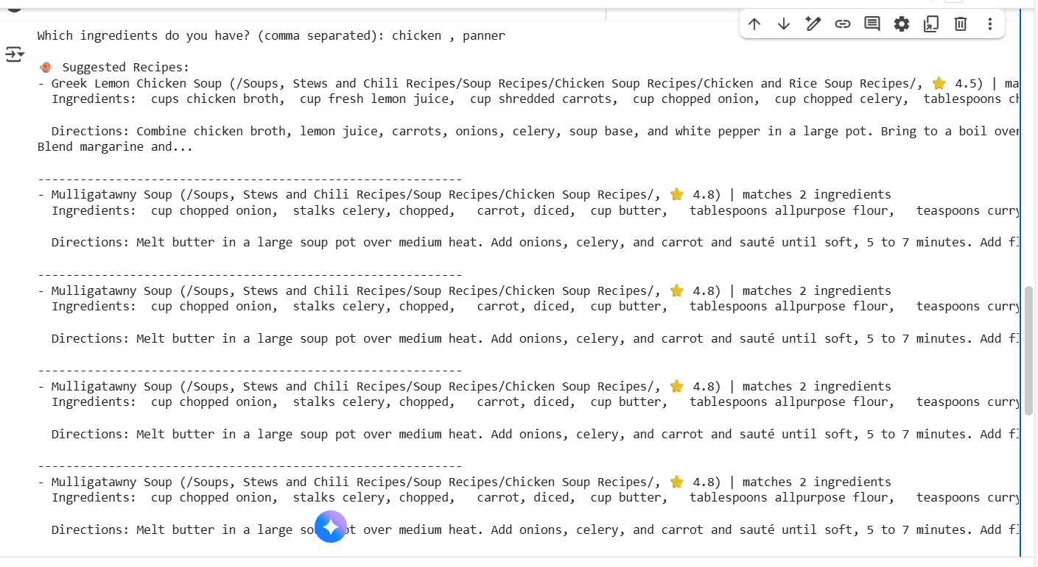

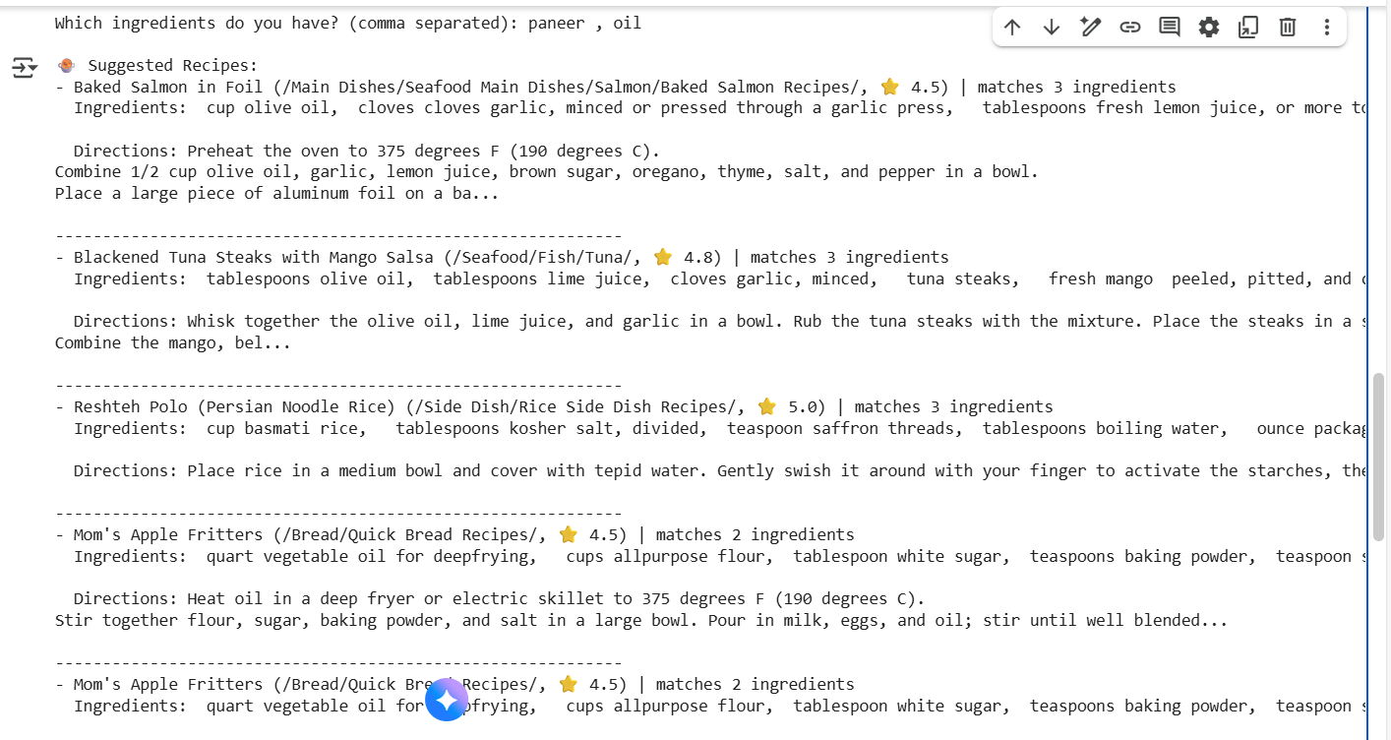

11]Conclusion:
The Recipe Generator successfully demonstrates an intelligent and user-friendly system for assisting users in meal preparation based on the ingredients they have. By taking user input, processing it, and matching it against a comprehensive recipe database, the system efficiently suggests recipes that maximize the use of available ingredients.
Key Takeaways:
- Ease of Use: The system requires minimal user input, making it intuitive for anyone to use.
- Efficiency: It quickly identifies and ranks recipes based on ingredient availability, saving time for users.
- Flexibility: The generator provides multiple recipe options, even with partial ingredient matches, accommodating varying user inventories.
- Accuracy: Fuzzy matching ensures robustness against typos and ingredient variations.
- Scope for Enhancement: The system can be expanded with features like ingredient quantity handling, dietary restrictions, nutritional information, and personalized recommendations.
Final Remark:
The Recipe Generator not only simplifies the process of deciding what to cook but also promotes creativity in using available ingredients efficiently. With further enhancements, it can evolve into a comprehensive culinary assistant, capable of guiding users from ingredient selection to meal preparation in a smart and personalized way.
https://github.com/Perfecthuma61/recipe-genearator.git

